Image Features I

- Line detection can be implemented as template matching, which consists in filtering images with masks responding to lines in different orientations, and then applying a threshold to select line pixels. Compare template matching with the Hough transform as methods to detect image lines.
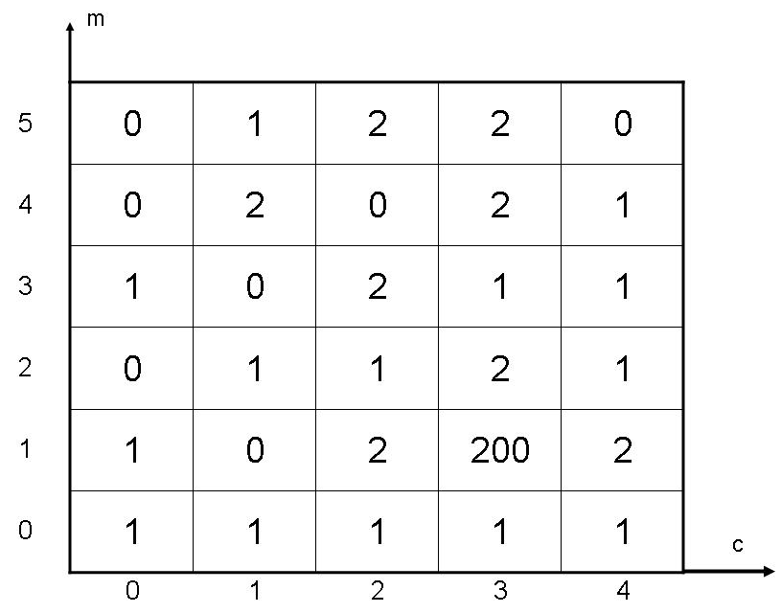
- Using the line equation y =m x +c and the Hough space shown, determine and draw the equation of the detected line(s) in the image space. How many edge points exist in the image? Why we cannot represent vertical lines in this Hough space?

